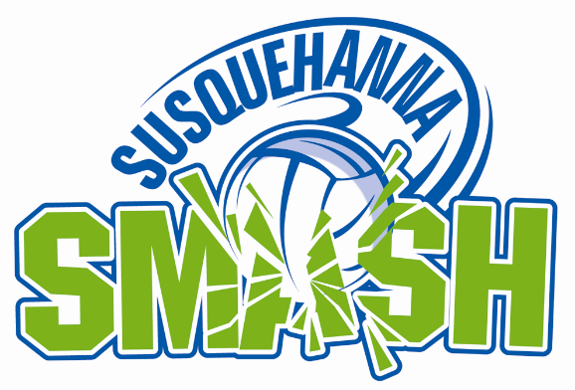

Susquehanna Smash

Volleyball Tournament
Friday, August 3rd, 2018
Saturday, August 4th, 2018
Sunday, August 5th, 2018

WAIVER AND RELEASE

I hereby request permission to participate in the Susquehanna Smash volleyball tournament on Friday August 3rd 2018 and/or Saturday, August 4th, 2018 and/or Sunday, August 5th, 2018.

If I am an amateur athlete who is/or will be subjected to the rules and regulation of the PIAA, the NCAA and other amateur athlete or scholastics organizations, I am aware that acceptance of any cash, savings bond of gift certificate awards won by me in this event can or may jeopardize my amateur status and my future ability to compete as an amateur athlete under the rules of such organizations.

In consideration of this entry being accepted, I intend to be legally bound, hereby for myself, my heirs, executors, administrators, waive and release any and all rights I may have against the organization holding this event, its agents, representatives, sponsors, successors and assigns for any all injuries suffered by me or damages arising out of or related to the Susquehanna Smash Volleyball Tournament.

I verify that I am physically fit and have trained sufficiently for the Susquehanna Smash Volleyball Tournament.

I grant permission to use any photographs of me and my name for any and all purpose. All of the foregoing has been read by the undersigned and has voluntarily been signed.

Entrant Name (Print) ________________________________________________________

Entrant Signature _____________________________________ Date_________________

Parent of legal guardian name (Print)_______________________________ Date __________
Parent or legal guardian signature if entrant is under 18 years old

____________________________________________________________
Signature

