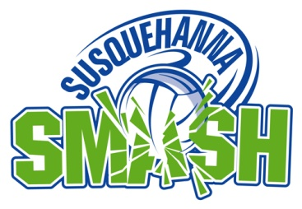
10TH ANNUAL
SUSQUEHANNA SMASH
VOLLEYBALL TOURNAMENT
AUGUST 3, 4 & 5, 2018
Saturday Doubles Divisions
PLEASE CHECK OFF THE DIVISION YOU ARE ENTERING [X]
[ ] REVERSE CO-ED AA | $70 | [ ] QUADS AA | $130
[ ] REVERSE CO-ED A | $70 | [ ] QUADS A | $130
[ ] REVERSE CO-ED BB | $70 | [ ] QUADS BB | $130
[ ] REVERSE CO-ED B | $70 | [ ] QUADS B | $130

* ALL PLAYERS UNDER AGE 18 MUST SUBMIT PARENTAL WAIVER FORMS
PLAYER 1  NAME _______________________________ | PLAYER 2  NAME _______________________________
ADDRESS ____________________________ | ADDRESS ____________________________
CITY ________________________________ | CITY ________________________________
STATE ________ ZIP _________________ | STATE ________ ZIP _________________
EMAIL ______________________________ | EMAIL ______________________________
PHONE ______________________________ | PHONE ______________________________
PLAYER 3  NAME _______________________________ | PLAYER 4  NAME _______________________________
ADDRESS ____________________________ | ADDRESS ____________________________
CITY ________________________________ | CITY ________________________________
STATE ________ ZIP _________________ | STATE ________ ZIP _________________
EMAIL ______________________________ | EMAIL ______________________________
PHONE ______________________________ | PHONE ______________________________

Please make sure to fill in all information completely and be sure it is LEGIBLE.
MAKE CHECK PAYABLE TO: SUSQUEHANNA SPORTS GROUP, LLC
PLEASE MAIL TO: SUSQUEHANNA SPORTS GROUP, LLC
23 SUNSET LANE
LITITZ, PA 17543

REGISTRATION MUST BE RECEIVED BY SUNDAY JULY 29TH OR YOU WILL BE CHARGED A LATE FEE OF $20. WALK-ONS WILL BE CHARGED ENTRY FEE PLUS ADDITIONAL $20 FEE.

